REMOVAL

1. | Drain the differential gear oil.

2. | Remove the rear disk brake.

3. | Remove the parking brake and cable.

4. | Remove the stabilizer bar.

5. | Pull out the rear axle shaft.  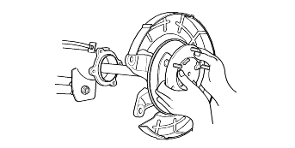
  Be careful not to damage the oil seal when pulling axle shaft.

6. | After marking the match mark on the flange yoke of the rear propeller shaft and the companion flange of the differential case, remove the rear propeller shaft assembly.  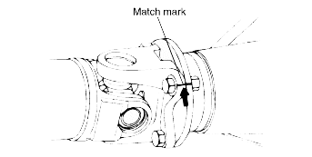
  Suspend the propeller shaft from the body with wire, etc.

7. | Remove the attaching nuts and strike the lower part of differential carrier assembly with a piece of times several times to loosen, then remove the differential carrier assembly.  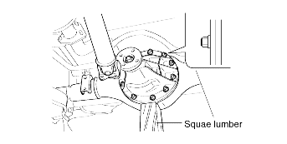
  Use care not to strike the companion flange.

INSTALLATION

1. | DIFFERENTIAL CARRIER ASSEMBLY  Apply specified sealant to axle housing flange surface, and install the differential carrier assembly.
  Specified sealant : Three bond 1215 or equivalent
  Tightening torque :
  23-27 Nm (2.3-2.7 kg·m,16-19 lb·ft)

2. | PROPELLER SHART  Align the match marks on the flange yoke and companion flange, and install the propeller shaft.
  Tightening torque :
  50-60 Nm (500-600 kg·cm, 37-44 lb·ft)

3. | AXLE SHAFT ASSEMBLY
  (1) | Apply specified sealant to the axle housing and bearing case end faces.
    Specified sealant : Three bond 1104

DISASSEMBLY

1. | SIDE BEARING NUT  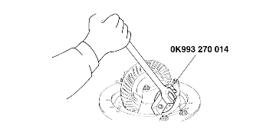
  Keep the right and left side bearing nuts separate so that they are not mixed during reassembly.

2. | REMOVAL OF THE DIFFERENTIAL CASE ASSEMBLY  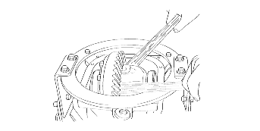
  a. | Remove the differential case assembly slowly and carefully.
  b. | Be careful so that the side bearing outer race is not dropped.
  c. | Keep the right and left side bearing outer races separate so that they are not mixed during reassembly.

3. | REMOVAL OF THE SIDE BEARING INNER RACES  Fit the nut on top of the differential case, and then uses the special tool to remove the side bearing inner race.  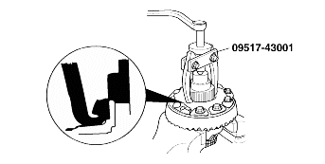
  Attach the prongs of the special tool (09517-43001) to the inner race of the side bearing through the notched section in the differential case.

4. | REMOVAL OF DRIVE GEAR  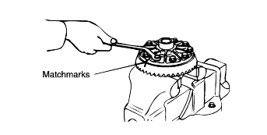
  a. | Make the match marks to the differential case and the drive gear.
  b. | Loosen the drive gear attaching bolts in diagonal sequence to remove the drive gear.

5. | REMOVAL THE LOCK NUT  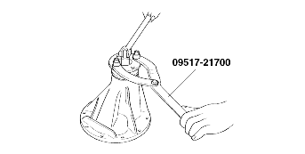

6. | REMOVAL OF DIRVE PINION  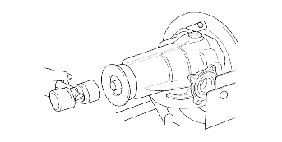
  a. | Make the match marks on the drive pinion and companion flange.
    Match marks should not be made on the contact surfaces of the companion flange and the propeller shaft.
  b. | Drive out the drive pinion together with the drive pinion spacer and drive pinion front shims.

7. | REMOVAL OF DRIVE PINION REAR BEARING INNER RACE  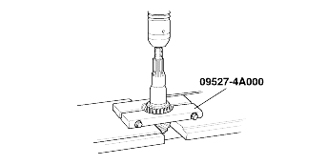

8. | REMOVAL OF OIL SEAR / DRIVE PINION FRONT BEARING INNER RACE / DRIVE PINION FRONT BEARING OUTER RACE  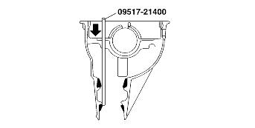

9. | REMOVAL OF DRIVE PINION REAR BEARING OUTER RACE  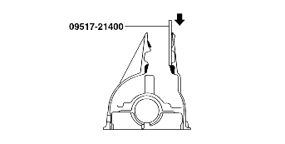

INSPECTION BEFORE DISASSEMBLY
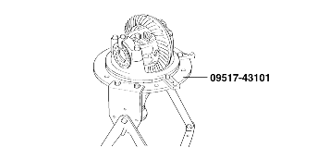
1. | FINAL DRIVE GEAR BACKLASH  Check the final drive gear backlash by the following procedure.
  (1) | Place the drive pinion and move the drive gear to check backlash is within the standard range.  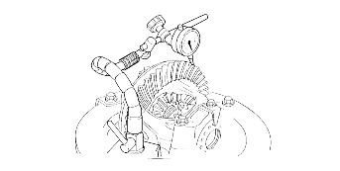
    Measure at 4 points on the gear periphery.
    Standard value
    0.13-0.18 mm (0.0051-0.0071 in.)
  (2) | Adjust with the side bearing nuts if backlash values are not within standard range.
    After adjusting, check the state of the final drive gear's tooth contact.

2. | DRIVE GEAR RUNOUT  Check the back-face lash as follows:
  (1) | Place a dial gauge on the back-face of the drive gear and measure the runout.
  Limit : 0.05mm (0.0020in.)
  (1) | 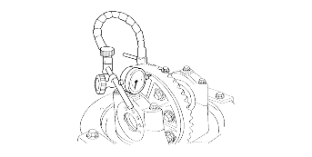
  (2) | If the run out is beyond the limit, check that there are no foreign substances between the drive gear and differential case and, that the bolts fixing the drive gear are not loose.

3. | DIFFERENTIAL GEAR BACKLASH
  (1) | Fix the side gear with a wedge so it cannot move and measure the differential gear backlash with a dial indicator on the pinion gear.  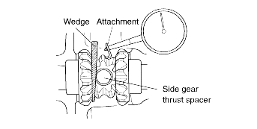
    Take the measurements at two places on the pinion gear.
    Standard value : 0-0.1 mm (0-0.0039 in.)
  (2) | If the backlash exceeds the limit, adjust using side bearing spacers.
    If adjustment is impossible, replace the side gear and pinion gears as a set.

4. | FINAL DRIVE GEAR TOOTH CONTACT  Check the final drive gear tooth contact by following the steps below :
  (1) | Apply the same amount of machine blue slightly to both surfaces of the drive gear teeth.  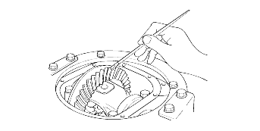
  (2) | Insert a brass rod between the differential carrier and the differential case, and then rotate the companion flange by hand (once in the normal direction, and then once in the reverse direction) while applying a load to the drive gear so that some torque (approximately 25-30kg·cm) is applied to the drive pinion.
    If the drive gear is rotated too much, the tooth contact pattern will become unclear and difficult to check.
  (3) | Check the tooth contact pattern.  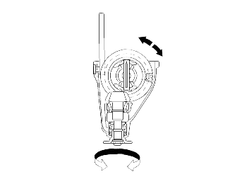

a. | 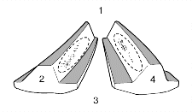
  Narrow tooth side
  b. | Drive-side tooth surface (the side receiving power during acceleration)
  c. | Wide tooth side
  d. | Coast-side tooth surface (the side receiving power during coast-down)
Problem | Solution
Tooth contact pattern resulting from excessive pinion height
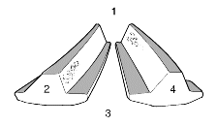 | 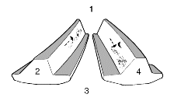
The drive pinion is positioned too far from the center of the drive gear. | Also, for backlash adjustment, reposition the drive gear further from the drive pinion.
Tooth contact pattern resulting from insufficient pinion height
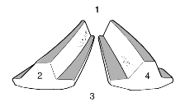 | 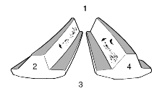
The drive pinion is positioned too close to the center of the drive gear. | Decrease the thickness of the pinion height adjusting shim, and position the drive pinion further from the center of the drive gear.  Also, for backlash adjustment, reposition the drive gear closer to the drive pinion.

a. | Tooth contact pattern is a method for judging the result of the adjustment of drive pinion height and final drive gear backlash. The adjustment of drive pinion height and final drive gear backlash should be repeated until the tooth contact patterns are similar to the standard tooth contact pattern.

b. | When you cannot obtain a correct pattern, the drive gear and drive pinion have exceeded their limits. Both gears should be replaced as a set.

INSPECTION

1. | Check the companion flange for wear or damage.

2. | Check the bearings for wear or discoloration.

3. | Check the gear carrier for cracks.

4. | Check the drive pinion and drive gear for wear or cracks.

5. | Check the side gears, pinion gears and pinion shaft for wear or damage.

6. | Check the side gear spline for wear or damage.

7. | Check the length of the distance piece.  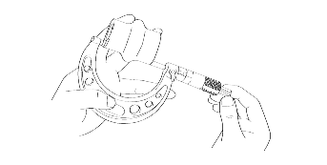
  Standard length :
  54.80-58.09 mm (2.16-2.21 in.)

REASSEMBLY

1. | Install the drive pinion rear bearing outer race and drive pinion front bearing outer race using the special tools (09500-11000, 09500-21000, 09532-31200B and 09532-32000).  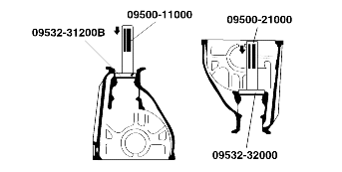
  Be careful not to press in the outer race when it is inclined.

2. | ADJUSTMENT OF PINION HEIGHT  Adjustment the drive pinion height by the following procedure.
  (1) | For assembly of pinion, use drive pinion model (0K993 270 A01), pinion height adjustment gauge body (0K993 270 A09) and gauge block (ht. 28 mm (1.102 in)).  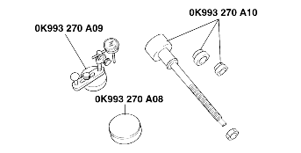
  (2) | Assemble spacer and inner bearing inner race to pinion model and fix it with O-ring.  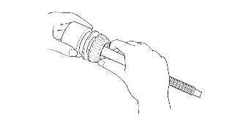
    a. | Use spacer disassembled.
  (3) | Install pinion model assembly to carrier.
  (4) | Assemble outer bearing, companion flange washer, and lock nut.
    a. | Use washer and lock nut disassembled.
  (5) | Tighten lock nut.  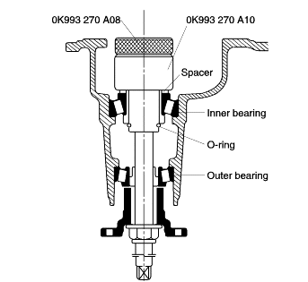
    a. | Tighten to the extent the companion flange can be screwed by hand.
  (6) | Put pinion height adjusting gauge body at right angle and adjust it to 0.  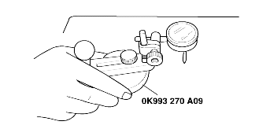
  (7) | Put pinion height adjusting gauge body and gauge block to the upper side of pinion model.
  (8) | Dial gauge needle should be placed at the lowest part of side bearing.
  (9) | Measure minimum positions of both sides (LH, RH).  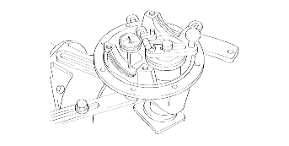
  (10) | Add both values and divide it by 2.
  (11) | If the value of the above step 10 is not within specification, use new spacer adding the values to current spacer.  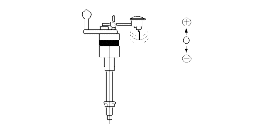
    Standard clearance :
    -0.025~0.025 mm (-0.001~0.001 in)
    MARK | THICKNESS | MARK | THICKNESS
    08  11  14  17  20  23  26 | 3.08(0.1212)  3.11(0.1224)  3.14(0.1236)  3.17(0.1248)  3.20(0.1259)  3.23(0.1271)  3.26(0.1283) | 29  32  35  38  41  44  47 | 3.29(0.1259)  3.32(0.1307)  3.35(0.1318)  3.38(0.1330)  3.41(0.1342)  3.44(0.1354)  3.47(0.1366)

3. | Adjustment of drive pinion preload.  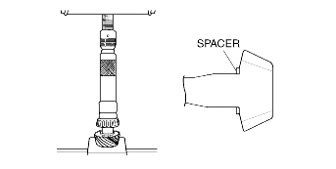
  (1) | Install spacer.
  (2) | Push inner bearing in using SST.
    a. | Keep pressuring until the sudden increase of necessary power.
    b. | Place the spacer for adjusting pinion height, ensuring exact direction of installation.
  (3) | Install distance piece.
  (4) | Push outer bearing in using SST.
  (5) | Install drive pinion assembly.
  (6) | Install companion flange and tighten lock nut.  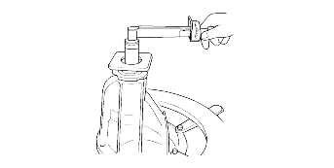
    Tightening torque :
    127-284 N·m (13-29 kg·m, 94-210 lb·ft)
    a. | Do not install oil seal.
  (7) | Turn companion flange by hand so that bearing be put at the right place.
  (8) | Measure preload of drive pinion. If the result is not within specification, use new distance piece and measure again.
    Preload :
    127-176 N·m (13-18 kg·cm, 94-130 lb·ft)
  (9) | Remove the lock nut and then install the oil seal.
  (10) | Install the companion flange and tighten lock nut.
    Tightening torque :
    127-284 N·m (13-29 kg·m, 94-210 lb·ft)
ADJUSTMENT OF DIFFERENTIAL GEAR BACKLASH
1. | Assemble the side gears, side gear spacers, pinion gears, and pinion washers into the differential case.

2. | Temporarily, install the pinion shaft.  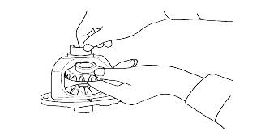
  Do not install the lock pin yet.

3. | Insert a wedge in the side gear and measure the differential gear backlash with a dial indicator on the pinion gear.  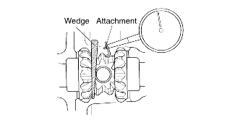
  Measure both pinion gears separately.
  Standard value : 0-0.1 mm (0-0.0039 in.)
  Limit : 0.2 mm (0.008 in.)

4. | If the differential gear backlash exceeds the limit, adjust the backlash by installing thicker side gear thrust spacers.

5. | Measure the differential gear backlash once again, and confirm that it is within the limit.
  a. | After adjustment, check that the backlash is within the limit and the differential gear rotates smoothly.
  b. | When adjustment is impossible, replace the side gear and the pinion gear as a set.

6. | Installation of the drive gear
  a. | Clean the drive gear attaching bolts.
  b. | Remove the adhesive on the threaded holes of the drive gear with a tap (M12 x 1.5), and then clean the threaded holes with compressed air.  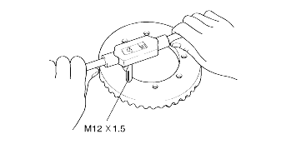
  c. | Apply the specified adhesive to the threaded holes of the drive gear.
    Specified adhesive :
    LOCTITE #262 or equivalent
  d. | Install the drive gear in the differential case with the matchmarks properly aligned. Tighten the bolts to the specified torque (11-15 kg·m) in a diagonal sequence.  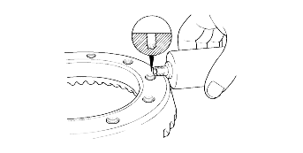

7. | Press-fit the side bearing inner race  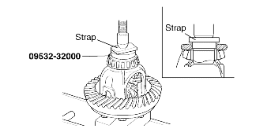

8. | Align the match mark on the gear carrier and the bearing cap, and then tighten the bearing cap.  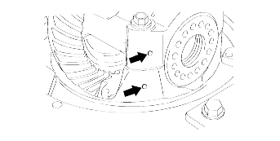

9. | ADJUSTMENT OF FINAL DRIVE GEAR BACKLASH  Adjust final drive gear backlash as follows :
  (1) | Using the special tool (09521-43001), temporarily tighten the side bearing nut until it is in the state just before preloading of the side bearing.
  (2) | Measure the final drive gear backlash.
    Standard value :
    0.13-0.18mm (0.0051-0.0071 in.)
    Measure at lease 4 points on the drive gear periphery.
  (3) | Using the special tool (09521-43000), adjust the backlash to standard value by moving the side bearing nut as shown.  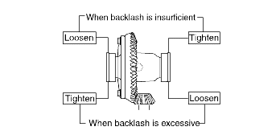
    First turn the side bearing nut for loosening, and then turn (by the same amount) the side bearing nut for tightening.
  (4) | Using the special tool (09521-43001) to apply the preload, turn down both right and left side bearing nut on half the distance between centers of two neighboring holes.  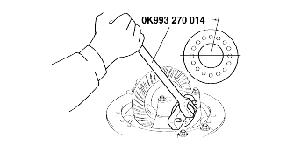
  (5) | Choose and install the lock plates two kinds.  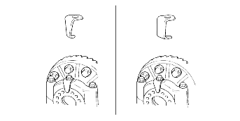
  (6) | Check the final drive gear tooth contact. If poor contact is evident, make adjustment.
  (7) | Measure the drive gear run out.
    Limit : 0.05mm (0.0020in.)
  (8) | When drive gear run out exceeds the limit, remove the differential case and then the drive gears, moving them to different positions and reinstalling them.

