QDS-Mini-Baja 9/04
 MODEL 780
AUTOMATIC
TORQUE CONVERTER

LAYOUT DIMENSIONS:
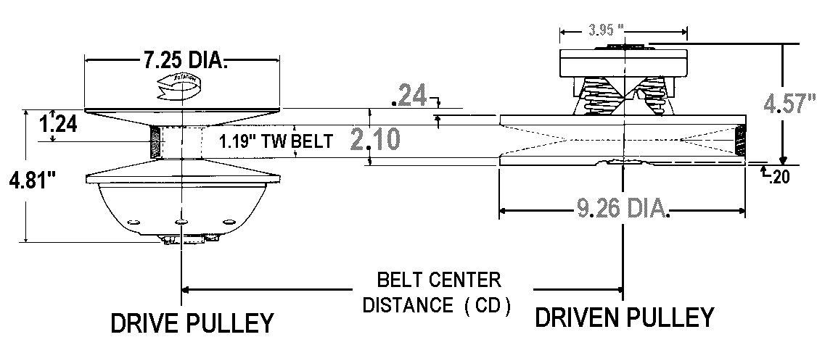
SPECIFICATIONS BELT SELECTION:

MAX ENGINE RATING: MAX RPM: PART NUMBER BELT C.D.
2-Cycle - 30 H.P. 10,000 300780C (704054) 8.59”
4-Cycle - 16 H.P 5,500 300634C (704055) 9.62”
300637C (704060) 10.73”
BORE SIZES SPEC. NO. 300638C (704061) 11.08”
DRIVE - 1” 302453C
DRIVEN - 3/4” 301789C

PULLEY RATIOS: DISCOUNTED NET APPLIES TO MINI
LOW - 3.71:1 (SHOWN ABOVE) BAJA PROJECT ONLY.
HIGH - .69:1 LIST NET*
OVERALL - 5.38:1 DRIVES : $270.00 $ 160.00
DRIVENS: 225.00 145.00
WEIGHT 14.5LB total BELTS : 71.00 43.00

*SHIPPING / TAXES:”FOB QDS” OR “FRT.COLLECT” / ADD 8.25 PERCENT TO PURCHASES IN CALIFORNIA ONLY.

NOTE: NEVER OPERATE A TORQUE CONVERTER WITHOUT A SUITABLE SAFETY SHIELD.

NOTE: DO NOT RUN AN ENGINE EQUIPPED WITH A DRIVE PULLEY IF THE BELT IS NOT ENGAGED WITH THE DRIVEN PULLEY.

DISTRIBUTED BY:____________________________________________ QDS P.O. BOX 6910 , ALHAMBRA , CALIFORNIA 91802 TEL. ( 626 ) 293-5770 / FAX. ( 626 ) 281-3392

