QDS-Mini-Baja 9/04
 MODEL 770
AUTOMATIC
TORQUE CONVERTER

LAYOUT DIMENSIONS:
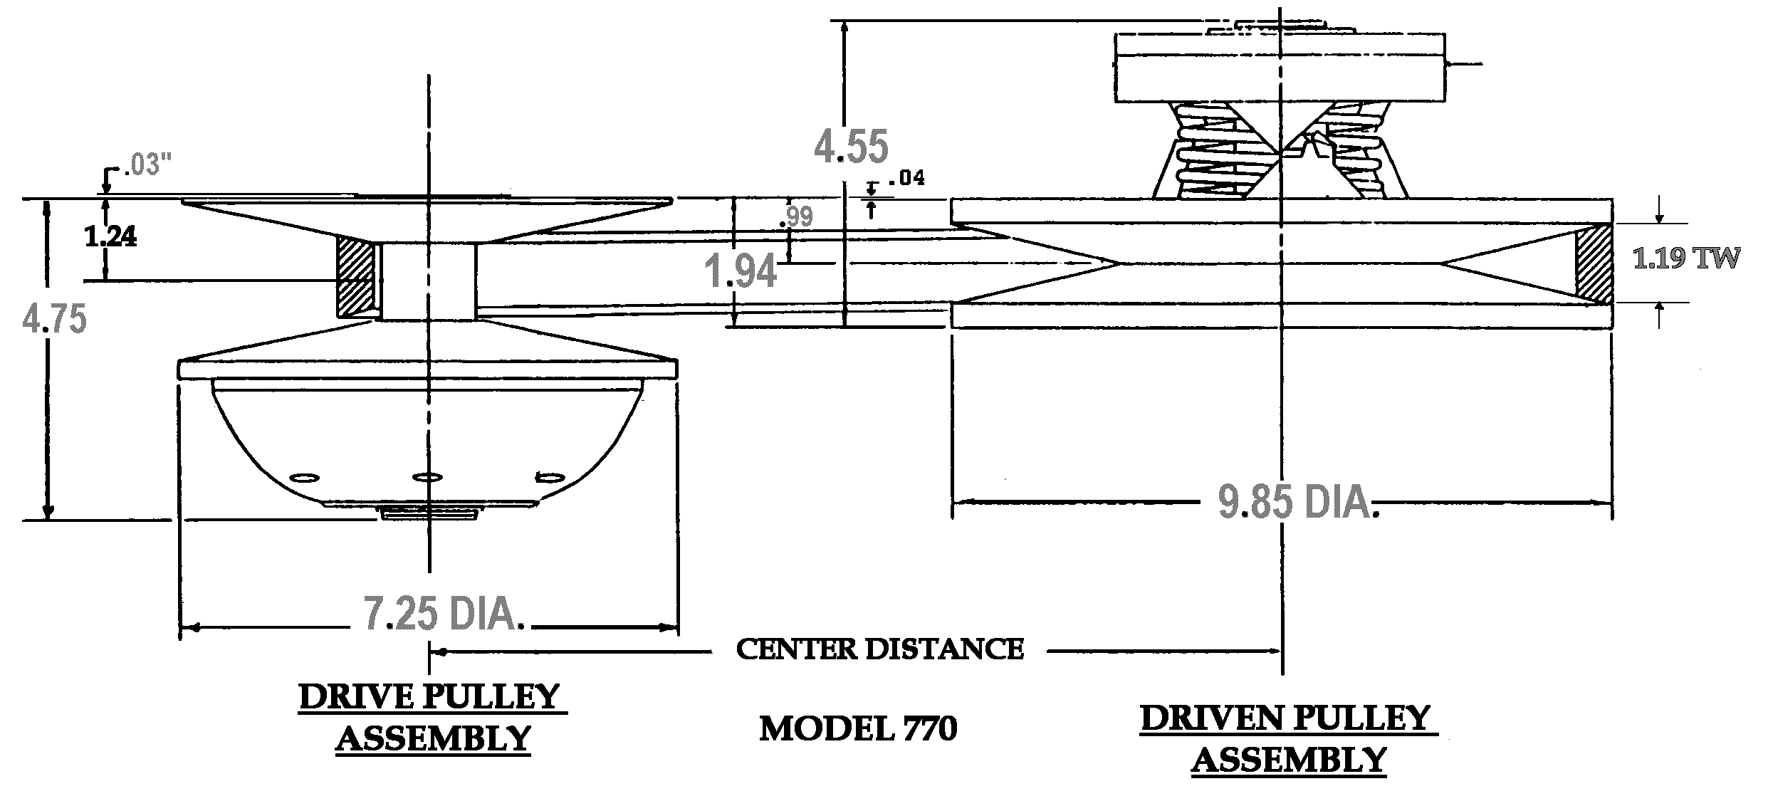

SPECIFICATIONS BELT SELECTION:
MAX ENGINE RATING: MAX RPM: PART NUMBER BELT C.D.
2-Cycle - 30 H.P. 10,000 300634C (704055) 9.02”
4-Cycle - 16 H.P 5,500 300637C (704060) 10.15”
300638C (704061) 10.50”
BORE SIZES SPEC. NO. 300663C (704096) 11.12”
DRIVE - 1” 302453C
DRIVEN - 3/4” 302604S

PULLEY RATIOS: DISCOUNTED NET* APPLIES TO MINI
LOW - 3.95:1 (SHOWN ABOVE) BAJA PROJECT ONLY.
HIGH - .76:1 LIST NET*
OVERALL - 5.20:1 DRIVES : $270.00 $ 160.00
DRIVENS: 250.00 150.00
BELTS : 71.00 43.00

*SHIPPING / TAXES:”FOB QDS” OR “FRT.COLLECT” / ADD 8.25 PERCENT TO PURCHASES IN CALIFORNIA ONLY.

NOTE: NEVER OPERATE A TORQUE CONVERTER WITHOUT A SUITABLE SAFETY SHIELD.

NOTE: DO NOT RUN AN ENGINE EQUIPPED WITH A DRIVE PULLEY IF THE BELT IS NOT ENGAGED WITH THE DRIVEN PULLEY.

DISTRIBUTED BY:____________________________________________ QDS P.O. BOX 6910 , ALHAMBRA , CALIFORNIA 91802 TEL. ( 626 ) 293-5770 / FAX. ( 626 ) 281-3392

