The Expert | DanaMATE.Com | Contact Us | Search
Make | Model | Year | Type
 | Found -> 3

Spicer No | Spicer Life | Loc. | Qualifier 1 | Qualifier 2 | Qualifier 3 | Qualifier 4 | Qualifier 5 | Qualifier 6 | Fig
5-153X | 5-785X | 2,3 |  |  |  |  |  |  | L,N
5-213X | 5-790X | 4,5 | Exc. Crew Cab w/Long Bed |  |  |  |  |  | L
5-213X | 5-790X | 4,5,6 | Crew Cab w/Long Bed |  |  |  |  |  | N
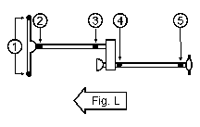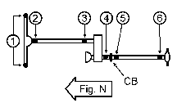

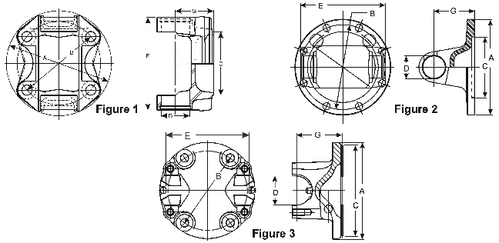
Identify Part by Dimension(J300P) More Information
Flange Yokes - Flange Yokes | Model/Part #: 2-2-1799
A.) Flange or Swing Dia. | 4.625
B) Bolt Circle Dia. | 3.750
Bolt Hole Dia. (NOM) | .406-D
Number of Bolt Holes | 4
C) Pilot Dia. M=male F=female | 2.559-M
G) Flange Face to C/L | 1.772
Figure | 1
10 mm bolt holes, equally spaced
Back to Identify Part by Dimension Menu

