Saginaw Steering Box Rebuild - Smooth Steering

From the January, 2008 issue of Four Wheeler
By Jay Kopycinski
Photography by Jay Kopycinski
The venerable Saginaw steering box has been in use for many decades and is found on a wide range of four-wheel-drives. A lot of 'wheelers with older rigs probably have one bolted to their framerail, doing its duty with competence each day they drive.
We have a Saginaw power-steering box of early-'70s vintage that finally blew a sector-shaft seal and had been weeping fluid for quite a while prior to that. So, we figured it was a good time for a teardown.
We sourced a rebuild kit from West Texas Off Road, and it included a complete set of seals with a heavy-duty top seal, and the input and output shaft bearings. With the box removed from the truck, we were ready to dive in.
A rebuild can be done with mostly common handtools. In any case, rebuilding a steering box requires patience and the assembly of many small parts and seals. Cleanliness and attention to detail will help ensure the result is a quality rebuild. Follow along as we show you the basics of how we cleaned, inspected, and reassembled our aging Saginaw.
For those of you who would rather not rebuild your own box, the folks at West Texas can do it for you. While they're in there, they can also tap the box, machine internal components, and add fittings for a hydraulic-assist upgrade. Other hydro-assist parts are also available if needed. If you have any doubt of your ability to rebuild a critical steering component such as this, leave the job to someone who's well experienced.
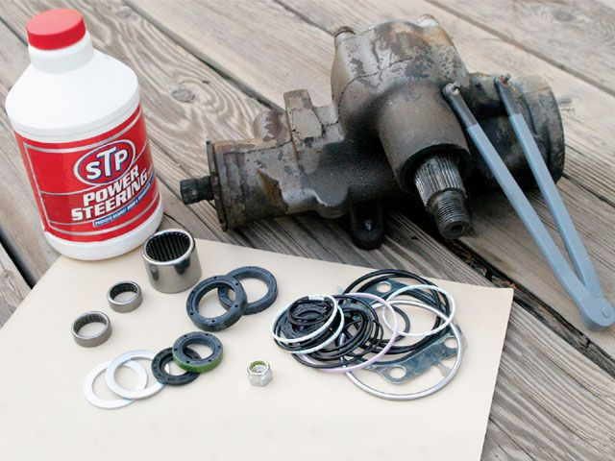

Saginaw Steering Box Components

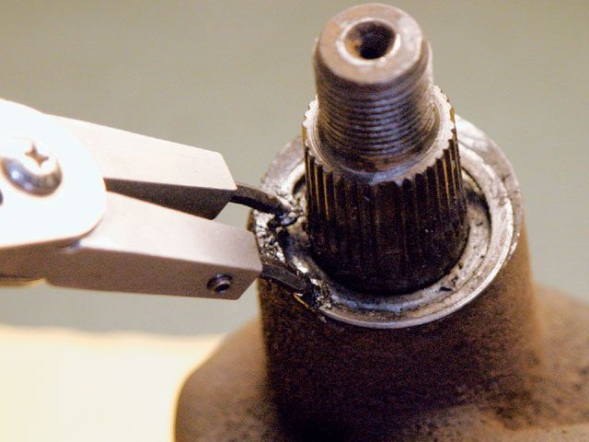

Saginaw Steering Box Remove C Clip
1. After the pitman arm has been centered in its rotational travel, it should be removed. Then the C-clip can be removed from the sector shaft using a set of snap-ring pliers. View Related Article

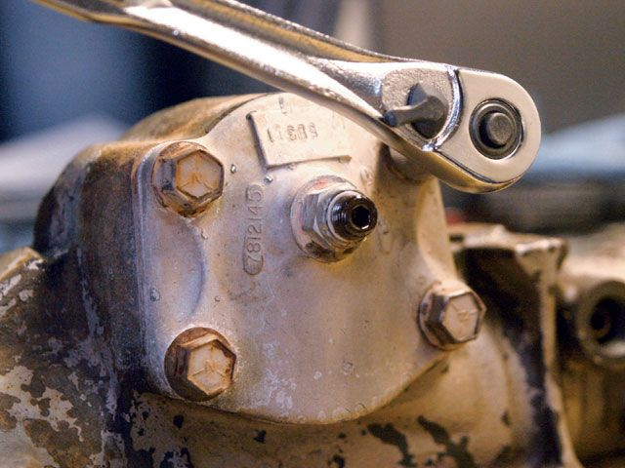

Saginaw Steering Box Remove Cover Bolts
2. The four bolts are removed from the cover on the top of the steering box.
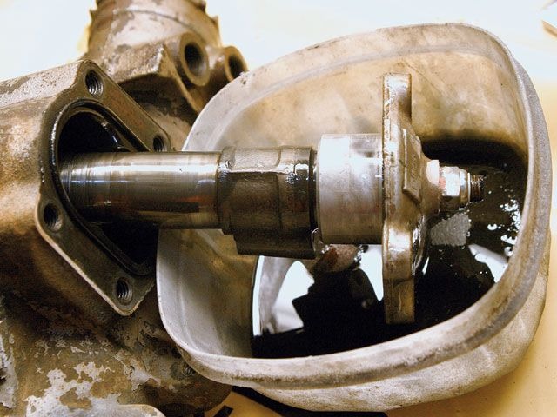

Saginaw Steering Box Sector Shaft
3. The sector-shaft assembly should lift out of the housing. If necessary, tap the lower end of the shaft with a soft-face hammer to get it to pop up. Fluid will pour out of the box, so have a catch pan ready.
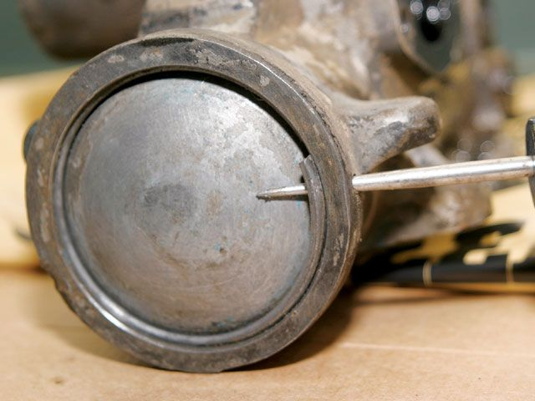

Saginaw Steering Box Inner Bore
4. Using an awl or similar tool, the steel retaining ring can be pushed from its groove and pulled off the inner bore. Rotate the stub (input) shaft in a left-turn direction to push the end plug out of the housing.
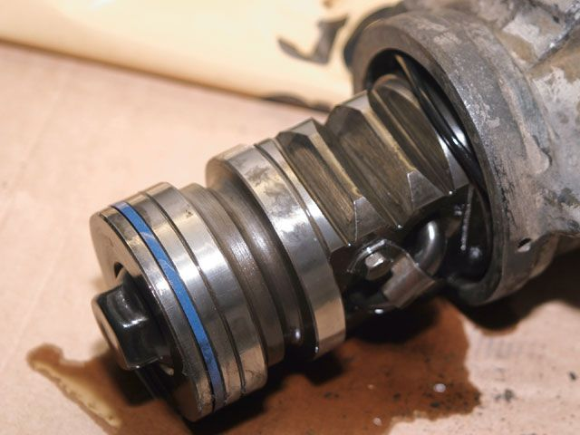

Saginaw Steering Box Rack Piston
5. Pull the rack piston out of the housing bore. More fluid will come out, and a set of steel ball bearings will fall out or into the inside of the rack piston. Be careful not to lose any.
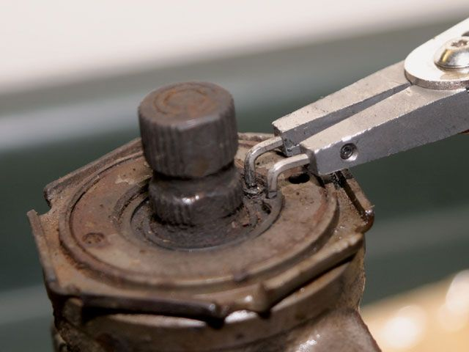

Saginaw Steering Box Adjuster Plug
6. Remove the C-clip from the adjuster plug. Each C-clip in the steering box will be replaced with a new piece.
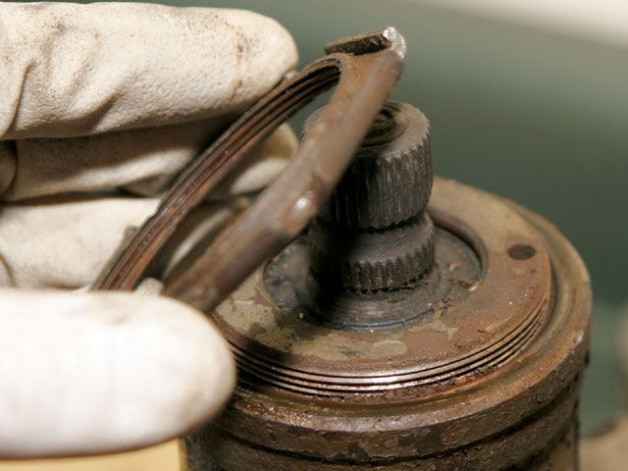

Saginaw Steering Box Remove Locknut
7. Using a brass drift or punch, loosen and remove the locknut from the adjuster plug.

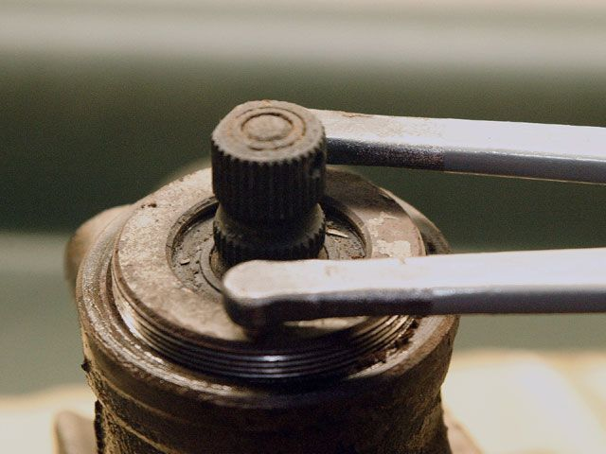

Saginaw Steering Box Remove Adjuster Plug
8. Using a spanner wrench (or similar tool), unthread and remove the adjuster plug and rotary valve assembly from the housing by pulling on the stub-shaft end.
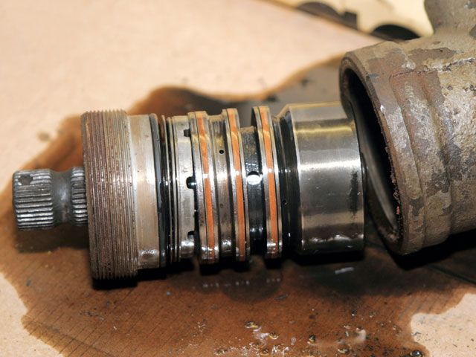

Saginaw Steering Box Rotary Valve Assembly
9. Here you can see the adjuster plug and rotary valve assembly, along with some more exiting fluid.
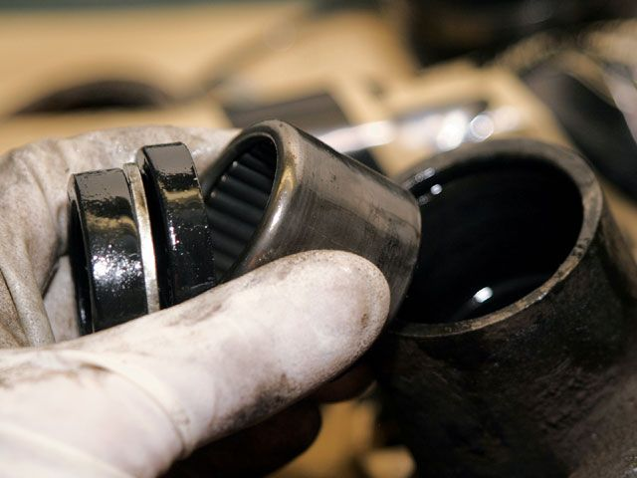

Saginaw Steering Box Pry Seals
10. Pry the two seals from the bottom of the housing where the sector shaft exits. Remove the seals, two washers, and then tap the needle bearing out of the housing bore.
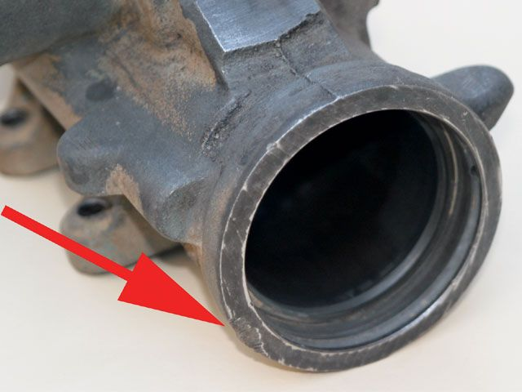

Saginaw Steering Box Check Housing
11. With the housing completely stripped down, it's a good idea to inspect its condition. Check for scoring or other anomalies in the interior bores. We found one damaged area here on our box from a rock scrape. Fortunately, it only scarred the exterior and did not affect any seal surfaces.
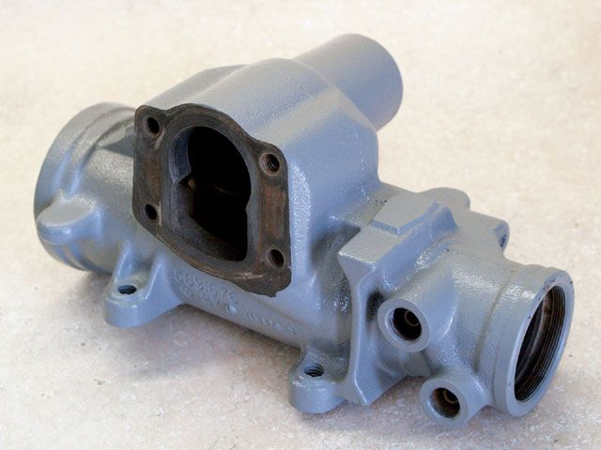

Saginaw Steering Box Reassemble Housing
12. With the box cleaned, inspected, and painted, it was ready for reassembly. All internal assemblies are taken apart as described, then inspected and cleaned before reassembly. Check for signs of nicks, burrs, or significant wear on the parts.
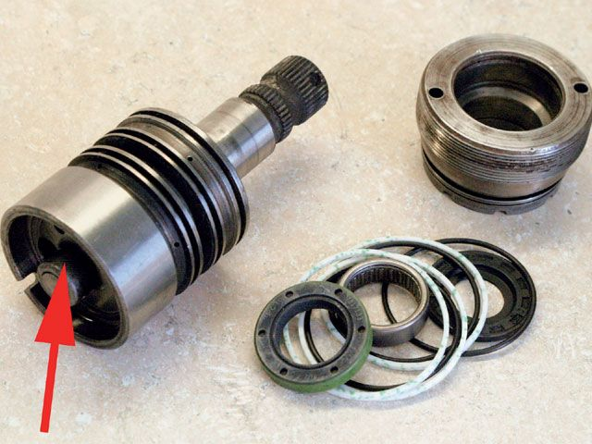

Saginaw Steering Box Remove Seals
13. Slide the adjuster plug off the stub shaft and remove the dust seal, oil seal, and needle bearing. Pull the three Teflon piston rings and their backup O-rings off the valve body. The arrow denotes a torsion-bar assembly that opens a fluid bypass when you turn the steering wheel too far to an end point. This assembly rarely needs service.
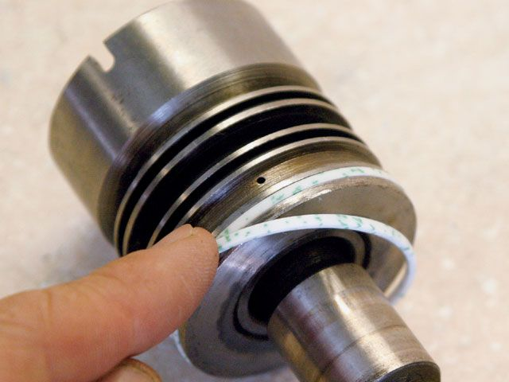

Saginaw Steering Box O Rings
14. Carefully stretch the O-rings onto the valve body and drop them in their respective grooves. Follow those with the three Teflon rings. A little fluid on each of the rings makes them go on easier and will help with initial sealing.
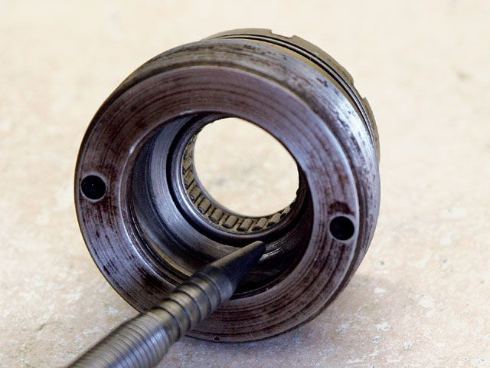

Saginaw Steering Box Needle Bearing
15. Press the new needle bearing into the adjuster plug bore so that the top is even with the bottom edge of the taper bore.

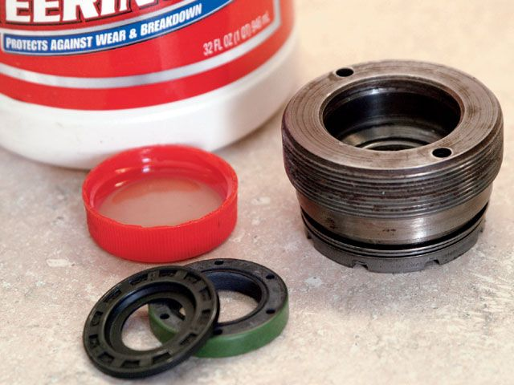

Saginaw Steering Box Oil Dust Seal
16. On top of the bearing, install the oil seal and dust seal by pressing them in place.
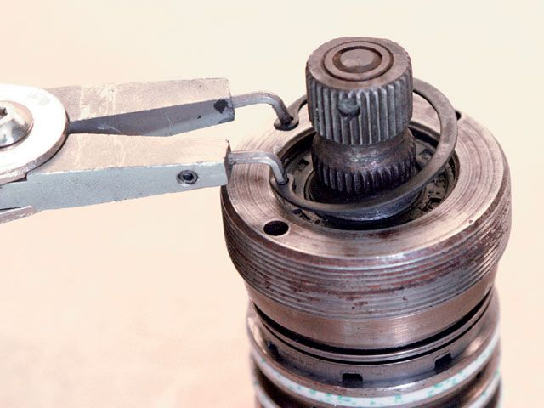

Saginaw Steering Box Adjuster Plug Seals
17. Apply some power-steering fluid to the adjuster plug seals and stub shaft and slide the stub shaft into the plug. Complete the assembly by installing a new C-clip.

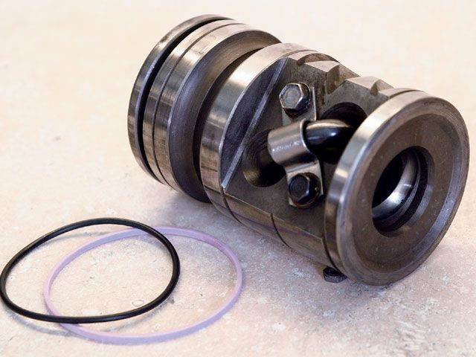

Saginaw Steering Box O Ring Piston Ring
18. A new O-ring and piston ring are provided for installation on the rack piston.
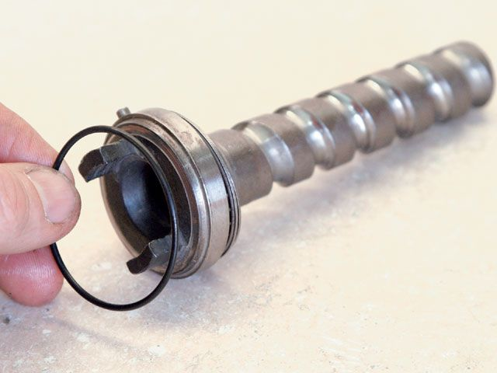

Saginaw Steering Box Steering Worm
19. Lube and place a new O-ring on the end of the steering worm.

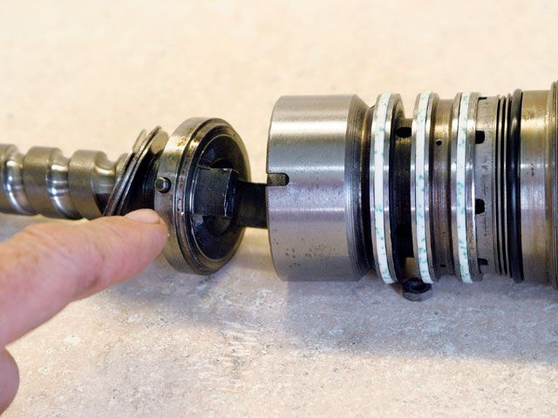

Saginaw Steering Box Worm Valve Body
20. Mate the worm to the valve body by aligning the tangs and side pin to slots in the valve body, ensuring the O-ring between the two seats properly.
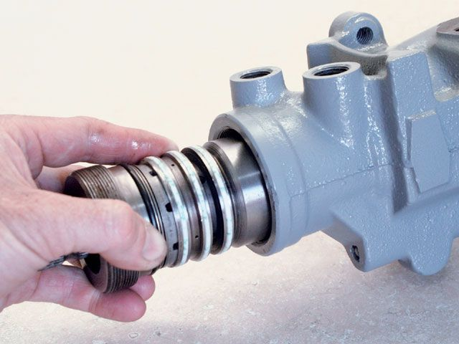

Saginaw Steering Box Assembly Housing
21. Now the assembly can be slid into the housing and the adjuster plug threaded into the bore. Do not push on the stub shaft while doing this installation. Again, adding a coating of fluid will aid assembly and allow the rings to slide smoothly against the metal.

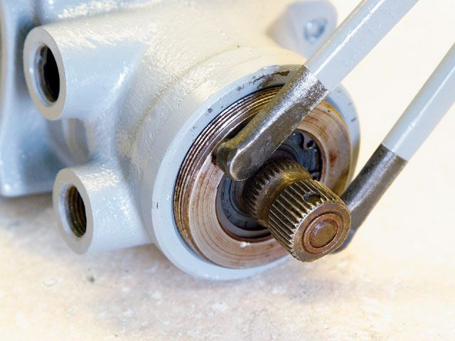

Saginaw Steering Box Tighten Adjuster Plug
22. Tighten the adjuster plug while checking for freeplay and smooth rotation of the stub shaft. Once the adjuster plug feels snug, then back it off just slightly.
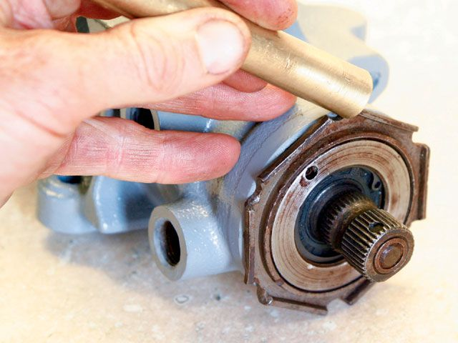

Saginaw Steering Box Install Locknut
23. With the adjuster-plug preload set, install the locknut and tap it snug using a brass drift or punch. Make sure the position of the adjuster plug does not change while doing this.
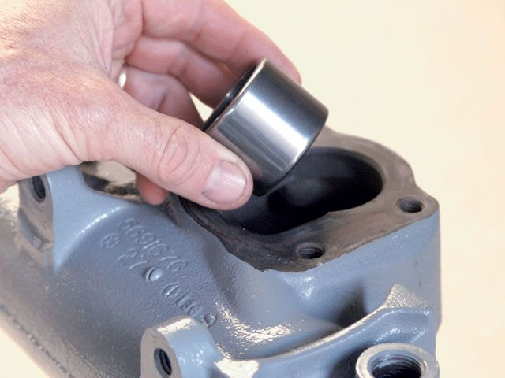

Saginaw Steering Box Insert Needle Bearing
24. A new needle bearing is inserted in the sector-shaft bore in the housing. Press or gently tap it down until it is flush with the inside face of the housing, looking down from above.
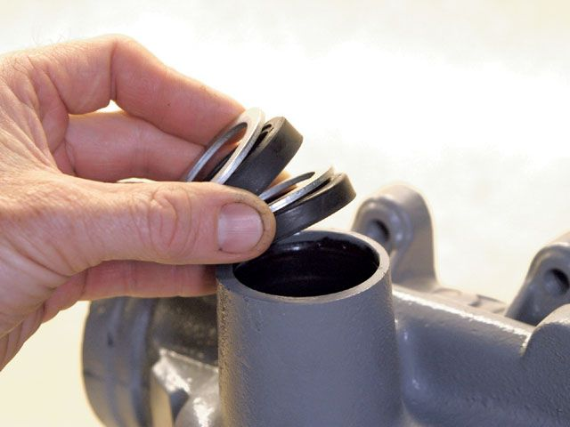

Saginaw Steering Box Install Oil Seals
25. Install the two oil seals (the double lip seal goes on the outside) and two washers in the sector-shaft bore at the bottom of the housing. Tap the seals in using a socket or similar tool. Install a new C-clip in the machined groove in the bore.
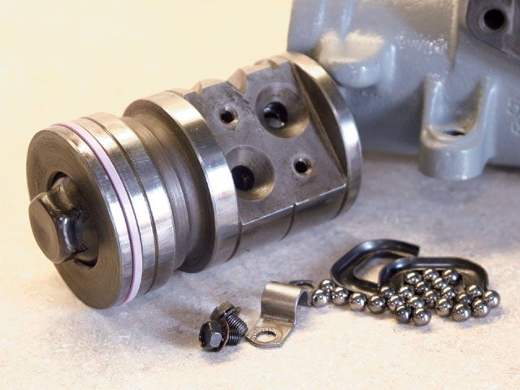

Saginaw Steering Box Tubular Ball Bearing
26. Here you can see that the tubular ball-bearing guide (two halves) and its attachment hardware have been removed from the rack piston. All those ball bearings (we counted 26) allow the worm and rack piston to move on each other. If you've ever heard stories about rebuilding a steering box, it's probably the ball-bearing install that you heard people whine about. It can be a little tricky. Some boxes use two slightly different (color and size) bearings. If yours has the two, install them by alternating them.
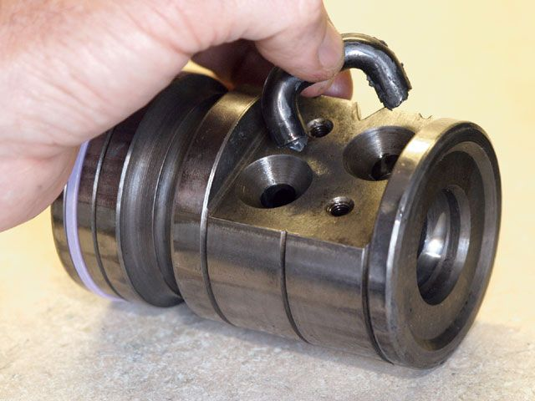

Saginaw Steering Box Guide Rack Piston
27. We put a little grease in the bearing guide and packed it with balls. We then reinstalled the guide in the rack piston. We applied some grease to the interior helix between the two guide holes, and pressed the remaining balls into this greased area. With all the balls in place, the rack piston can be slid into the housing bore and the worm turned into the piston helix by turning the stub shaft and pushing the piston into the housing. You may want to consider removing the hex end plug to watch and make sure no balls fall out of place.
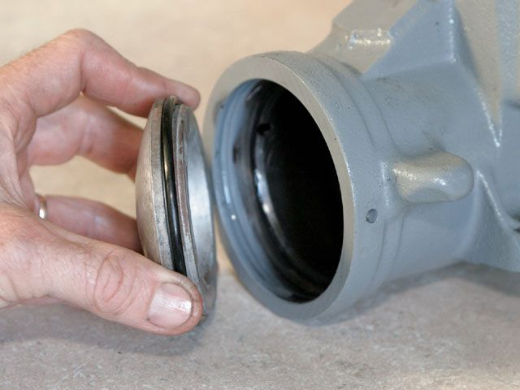

Saginaw Steering Box End Plug
28. Once the rack piston is in the housing, the end plug can be reinstalled using a fresh O-ring.
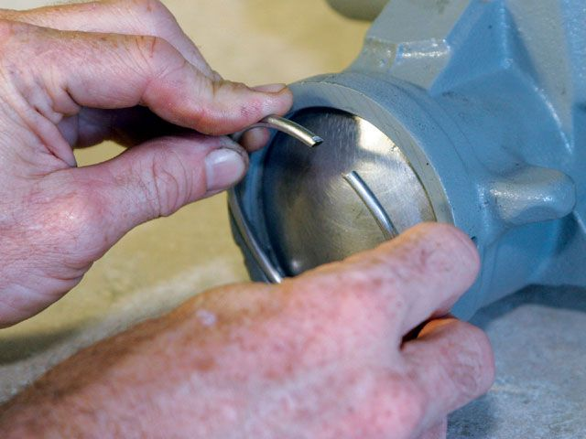

Saginaw Steering Box Retainer Ring
29. Install a new retainer ring. One way is to hold the ring partially in the groove and lightly tap around it to push it completely down into the bore groove.
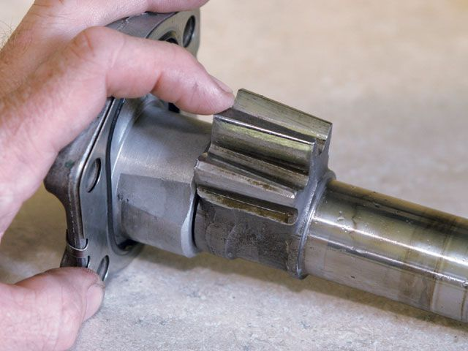

Saginaw Steering Box Rack Teeth
30. As with all the other parts, inspect the sector shaft for any abnormal wear or damage. Check the rack teeth for signs of galling or other problems. Install a fresh locknut and O-ring gasket on the cover plate.
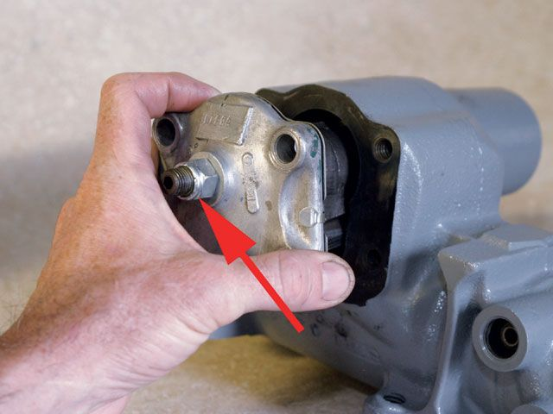

Saginaw Steering Box Install Sector Shaft
31. With the rack piston roughly centered in its travel, the sector shaft can be reinstalled. Apply a little fluid to the meshing teeth and to the smooth shaft area that mates with the lower seals. Replace the four bolts in the cover.
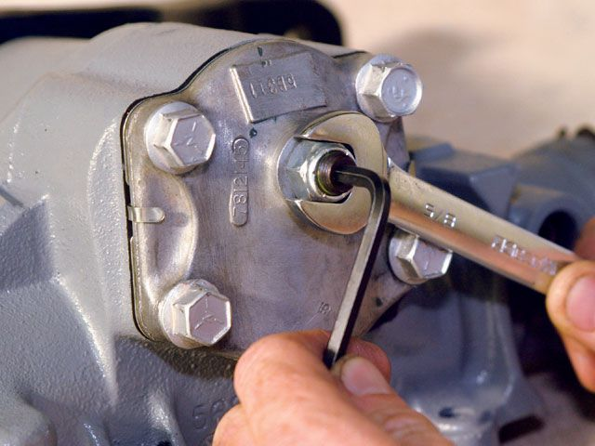

Saginaw Steering Box Adjust Sector Shaft Tension
32. The final step is to adjust the sector-shaft tension. To begin, center the steering on the high point. Adjust the screw until the box steers freely except for slight touching at the center point. From there, back the screw off about 25 degrees and tighten the locknut.
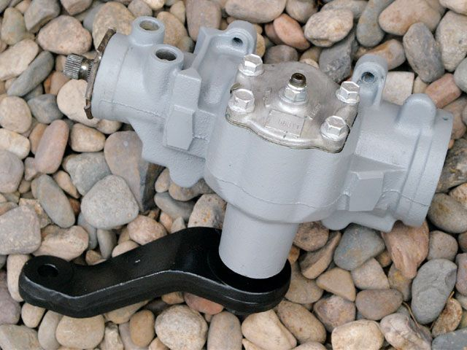

Saginaw Steering Box Rebuilt Steering Box
33. With the steering box rebuild complete, it can be reinstalled on your rig. After a short drive, recheck the sector-shaft adjustment. At the steering box, turn the steering shaft back and forth slightly by hand and observe the movement of the pitman arm. There should be little freeplay in the steering shaft, and the pitman should move immediately, matching the movement of the steering shaft.
http://www.fourwheeler.com/techarticles/drivetrain/129_0801_saginaw_steering_box_rebuild/index.html

