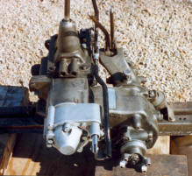
Benefits of the Saturn Overdrive
Increases Engine & Drivetrain Life
Reduces Engine RPM by 25%
Improves Gas Mileage
No Driveline Modifications
Can be used in Overdrive of Direct
One (1) Year Warranty

